

TITLE

Smart Vest: A wearable device that helps blind people find obstacles at head level

AUTHORS

Adam Nuruddin Bin Helmi (2215783), Nur Fatihah Hannani binti Hasmayadi (2227062), Nur Syahzman Aziq Bin Mohd Shahmadi (2310037), Department of Mechatronics Engineering, International Islamic University Malaysia Email: hannani.hasmayadi@live.iium.edu.my

ABSTRACT

This paper describes how to design and build a Smart Vest, a wearable mechatronic system for detecting obstacles in the upper body that is meant to help people who are blind or have low vision. The proposed system uses a simplified two-tier architecture to make it more reliable, easier to set up, and less complicated. The main controller is an Arduino UNO microcontroller that handles real-time distance detection, decision-making, and feedback activation. A TF-Luna LiDAR sensor sends distance measurements to the microcontroller via UART. A HuskyLens module, on the other hand, uses AI to recognise objects and sends data directly to the microcontroller. A laptop is only used for AI training, setting up the system, and keeping an eye on things, which reduces the need for outside help while the system is running. When the system sees something in the user's upper body area, it immediately and clearly warns them with a buzzer and LED lights. Experimental results show that the proposed Smart Vest works well for fast-response alerts and intelligent perception through easier system integration. It has low response latency, stable operation, and accurate obstacle detection.

- INTRODUCTION
This project uses a structured and systematic design method to create a wearable Smart Vest that can find obstacles in the user's upper body and help visually impaired people find their way. Visual impairment is still a big problem around the world. It makes it harder to move around, be independent, and stay safe, especially in new outdoor settings [1]. Wearable assistive technologies have become more popular because they could help people who are blind become more aware of their surroundings in real time and improve their quality of life.

Previous research has demonstrated that affordable, sensor-driven wearable assistive technologies can efficiently aid visually impaired individuals by providing prompt obstacle detection and user-friendly feedback. Arduino-based wearable solutions have shown that they can work well in real time while still being simple, portable, and cheap [2]. Smart assistive devices that use sensors also stress the importance of being able to work on their own and integrating sensors well, which makes it possible to navigate outdoors without having to rely on external computing platforms all the time [3]. Studies on wearable vest-based and body-mounted assistive systems bolster the efficacy of torso-mounted designs, which offer stable sensor positioning, enhanced comfort, and simplified integration relative to head-mounted devices [4].

The Arduino UNO microcontroller is the heart of the proposed Smart Vest system. It collects, processes, and controls the output devices. To make the system more reliable and easier to design, a simplified two-tier system architecture is used. This makes it suitable for continuous wearable assistive use [5]. A TF-Luna LiDAR sensor detects obstacles in the user's upper body by using Time-of-Flight (ToF) technology to accurately measure distances to nearby objects. Also, a HuskyLens vision sensor is built in to do AI-based object recognition on its own and talk directly to the microcontroller. You only need a personal computer or laptop during the AI training and setup phase. The system can run on its own after that [6].

When it's running, the Arduino UNO processes data from sensors in real time and turns on warning systems when it sees something that is too close to the safety threshold. LED lights and a buzzer give users feedback right away, letting them know what's going on. The alert's intensity changes based on how far away the object is, making it easy to tell how close an obstacle is. Testing with different distances between obstacles and user movement shows that the Smart Vest can quickly and accurately detect obstacles in the upper body, making it useful for assistive applications.

The Smart Vest is made to help people who are blind or have low vision move around outside, where things like signboards, tree branches, poles, and structures that stick out can be dangerous for the head and upper body. The proposed system focusses on upper-body safety, which is very important in complicated outdoor settings, unlike most mobility aids, which only focus on hazards at ground level. The Smart Vest improves mobility for blind people by giving them real-time feedback and making them more aware of obstacles. This boosts their confidence, independence, and overall safety.

- METHODOLOGY

2.1 Project Development

In order to create a wearable Smart Cap for head-level obstacle detection, this project employs an organized methodology. An Arduino UNO microcontroller, which manages data collecting, processing, and output actions, is at the heart of the system. Reliability is increased, and total system complexity is decreased by using a streamlined two-tier system architecture. The TF-Luna LiDAR sensor uses Time-of-Flight (ToF) technology to measure distance in order to identify obstructions at head level. Additionally, the HuskyLens module, which runs autonomously and interacts directly with the microcontroller, performs AI-based object recognition. A PC or laptop is not necessary for regular operation; it is only used during the AI training and configuration phase.

The Arduino UNO processes sensor data in real time. The system initiates warning mechanisms when it detects an obstruction within a predetermined distance threshold. These alerts include LED indicators, buzzers, and vibration motors that give the user instant tactile, auditory, and visual input. An intuitive awareness of the surrounding environment is made possible by the warning strength, which changes based on the observed distance. To assess detection accuracy and response time, the system is tested under various obstacle distances and user movement scenarios. The findings show that the Smart Cap can provide quick and accurate head-level obstacle detection, which qualifies it for assistive applications for those with vision impairments.
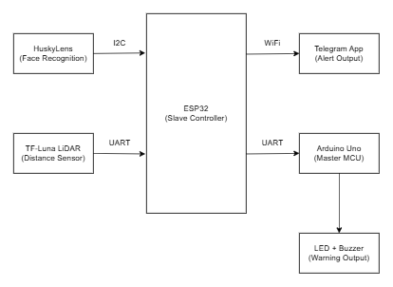

Fig.1 Overall block diagram (drawio)

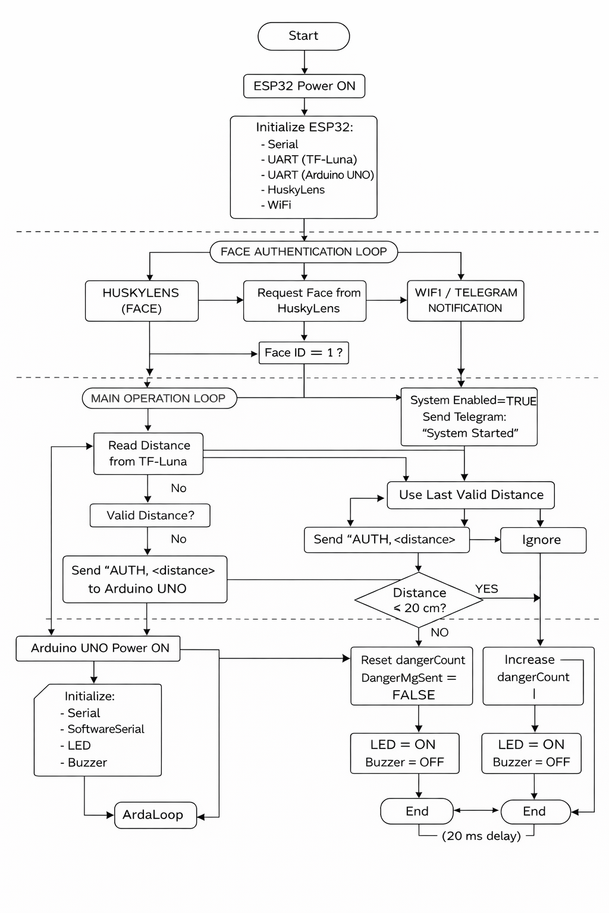
Fig. 2 The flow chart that explains all the work principles for the Smart Cap project (Chatgpt)

2.2 Schematic Diagram and Prototype Setup

Figure 3 presents the electrical schematic of the Smart Cap system, which integrates sensing, processing, and feedback components using a dual-controller architecture. The ESP32, mounted on the cap, manages real-time obstacle detection, AI vision input from the HuskyLens, and actuation of output devices such as buzzer and RGB LED indicators. Distance measurements are obtained using a TF-Luna LiDAR sensor, while an Arduino UNO mounted on the wearable cloth handles auxiliary sensing and power distribution. A portable power bank supplies a regulated 5 V source to ensure system mobility. Figure 4 shows the physical prototype implementation, where cap-mounted components enable head-level obstacle detection and visor actuation for physical protection, while cloth-mounted components reduce head load and improve user comfort. This configuration enhances system reliability, wearability, and suitability for assistive applications.

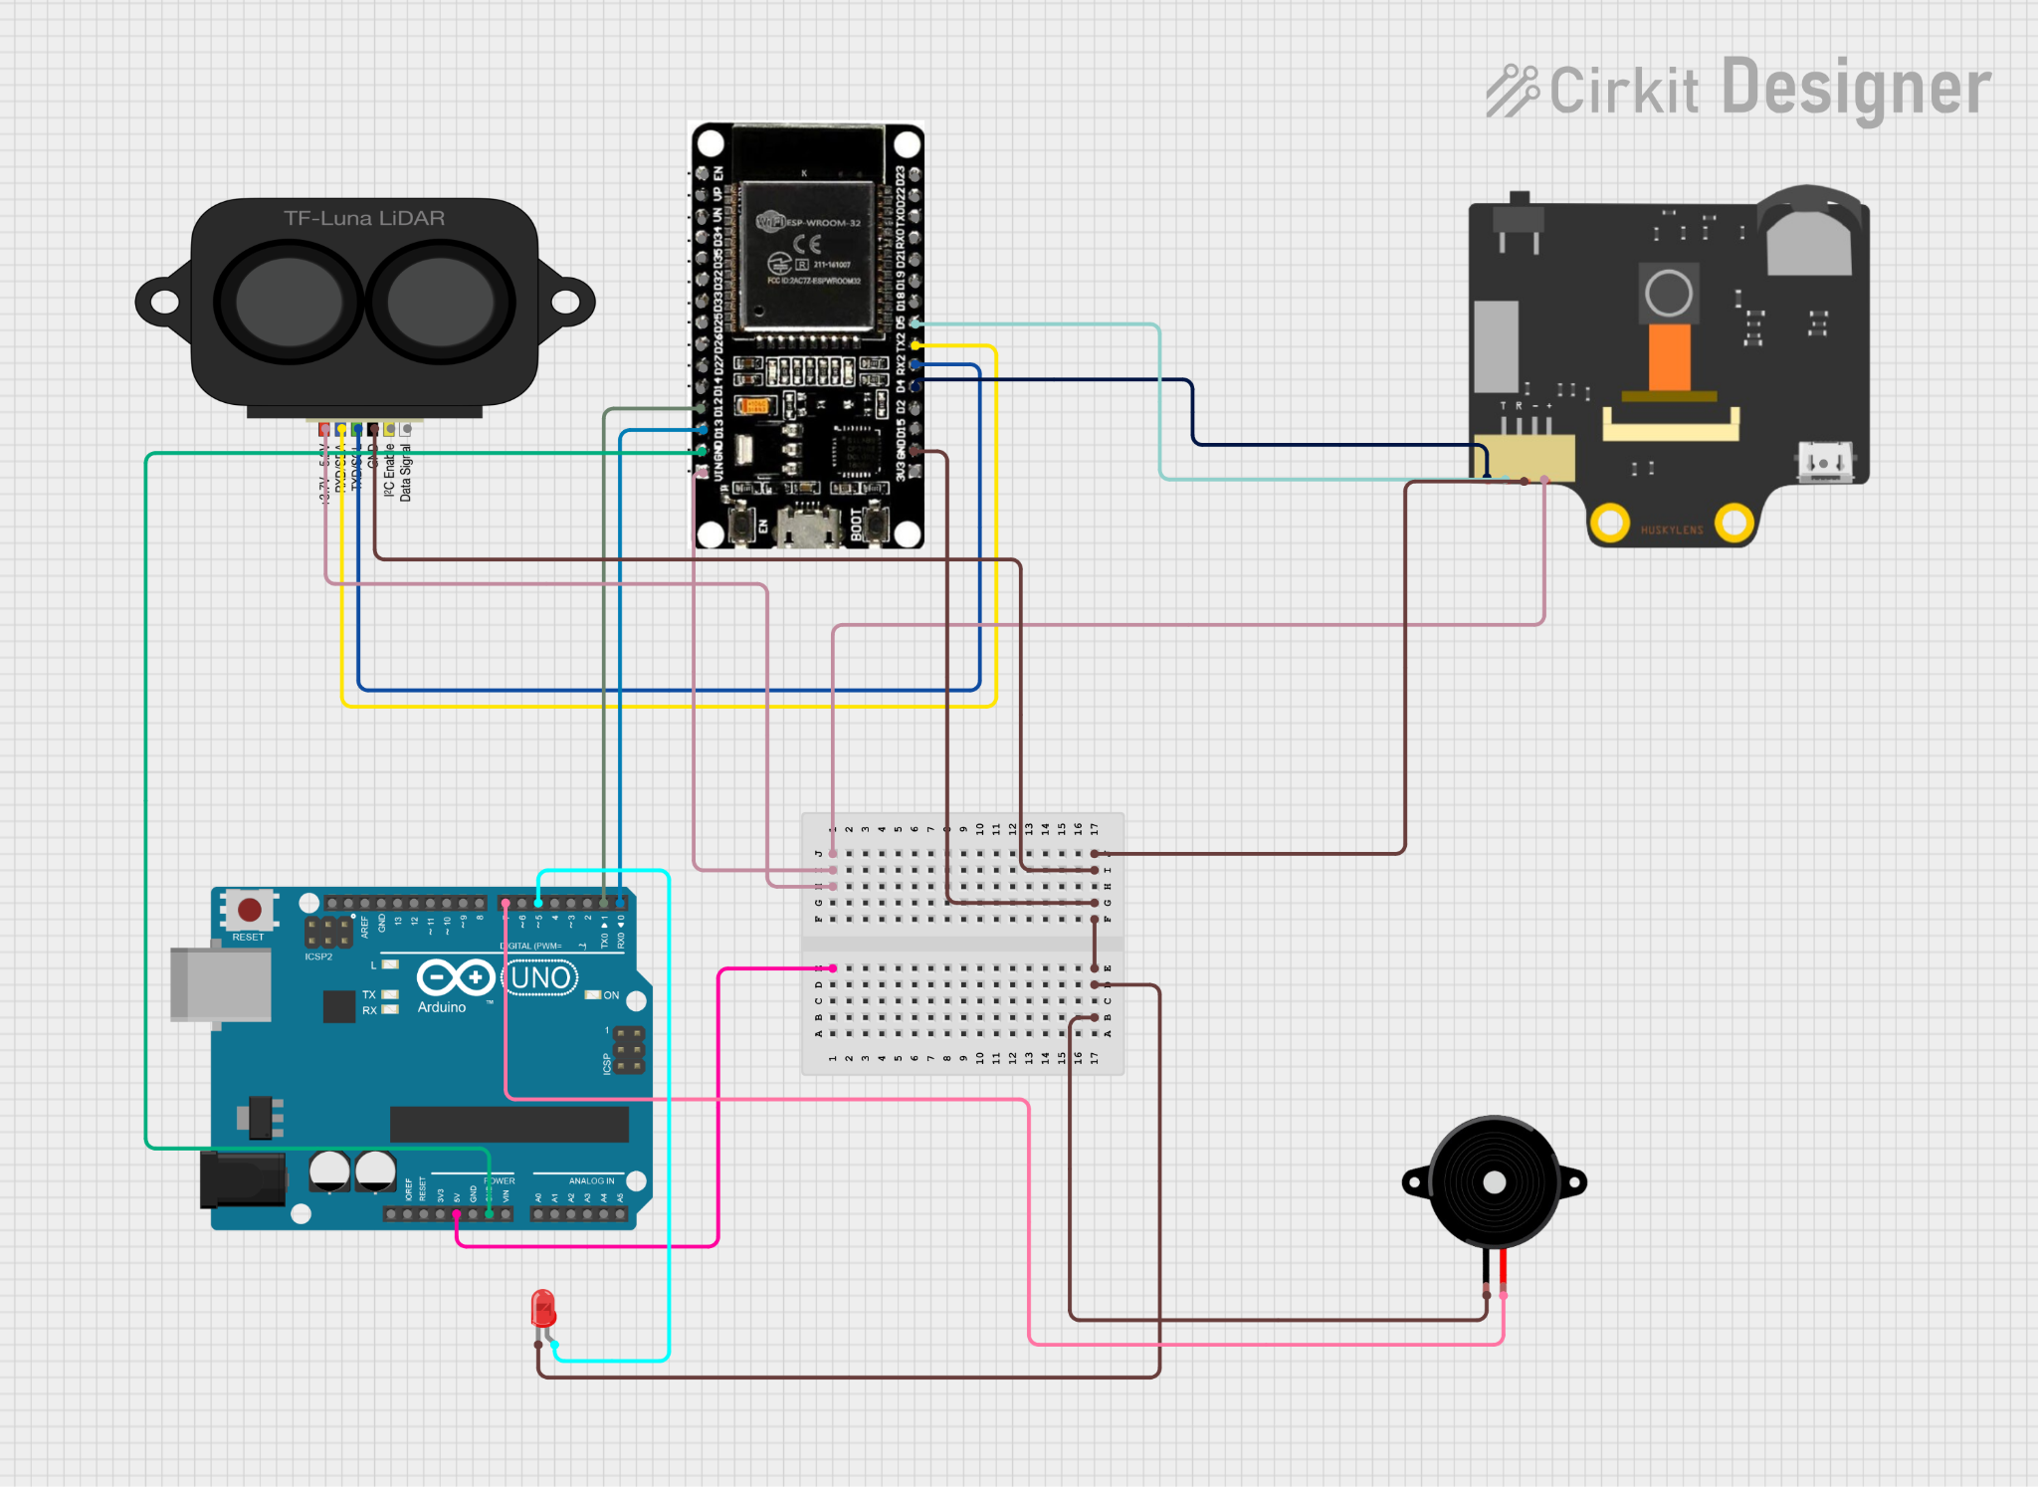

Fig. 3 Electrical Design of the Smart Vest project

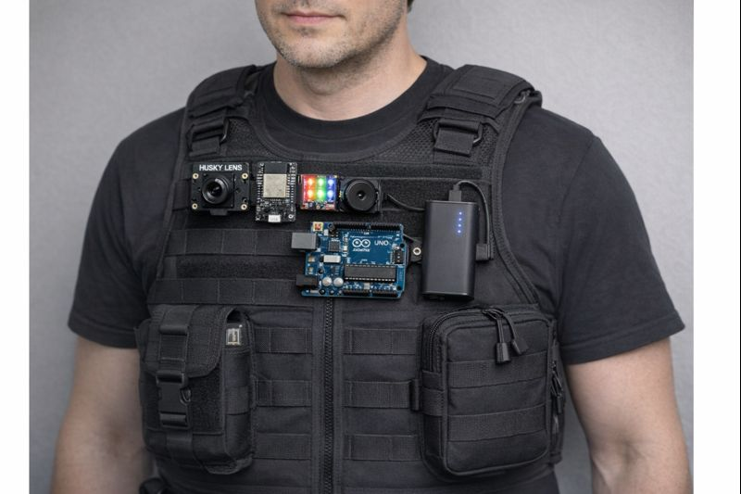

Fig. 4 The Smart Vest (Chatgpt)

- RESULT AND DISCUSSION

3.1 System 1 (Proximity Warning and Lighting System) Analysis

Results

The results from System 1 show that the proximity warning and lighting system works well because the distance sensor gives accurate distance readings. The system keeps an eye on the distance between the user and other things in the area all the time. It then compares the measured values to a set threshold of 20 cm. The system stays in a normal operating state when the detected distance is greater than this limit, and both the LED and buzzer are turned off.

When the distance gets shorter and gets to or below 20 cm, there is a clear and immediate response. When the distance is 10 cm or less, the LED lights up to give a visual warning, and the buzzer makes a sound to alert you. This shows that the threshold-based logic works as it should and that the system can tell the difference between safe and unsafe proximity conditions. Similar threshold-based proximity systems have been documented to offer dependable obstacle detection for assistive technologies (Kumar et al., 2024; Keerthi et al., 2023).

The LED and buzzer going off again and again during sustained close-range detection shows that the system is stable and consistent. The results show that there is very little delay between detecting an object and responding, which means that the processing is quick and the performance is in real time. Such quick feedback is important for assistive devices that help people who are blind or have low vision, since delayed responses could put users at risk (Anik et al., 2021).

The results show that the 20 cm threshold works well for giving timely warnings and cutting down on false alarms when people are moving around normally.

Discussion

The proximity warning and lighting system is very important for improving situational awareness because it lets users know about nearby obstacles through both sound and sight. Choosing a 20 cm threshold is ideal for detecting obstacles at close range because it gives you enough time to react and doesn't send out alerts when objects are far away. Previous research on assistive walking aids has shown that close-range thresholds work well to keep people from running into each other and make them feel more confident while they are walking (Elmannai & Elleithy, 2017).

When you use both LED and buzzer outputs, you get a dual-alert system that makes the system more reliable in different kinds of weather. The LED gives you immediate visual feedback, which is helpful in quiet or low-noise places. The buzzer makes sure that warnings are still heard when visual cues may not be enough. Multi-modal feedback systems have been demonstrated to substantially improve the efficacy of assistive devices for individuals with visual impairments (Anik et al., 2021; SpringerLink, 2023).

The system works well most of the time, but small changes in distance readings can happen because of sensor noise, surface reflectivity, or the environment. But the clearly defined threshold makes sure that these changes don't have a big impact on how well the system works. Future enhancements may involve averaging multiple sensor readings or employing hysteresis logic to mitigate false triggering, as indicated in previous sensor-based assistive system research (Elmannai & Elleithy, 2017).

In short, System 1 meets its goal of providing a simple, responsive, and effective way to warn people when they are too close to something. The system is great for assistive apps, especially when it comes to making sure users are safe when they are navigating through areas with low visibility or a lot of stuff.

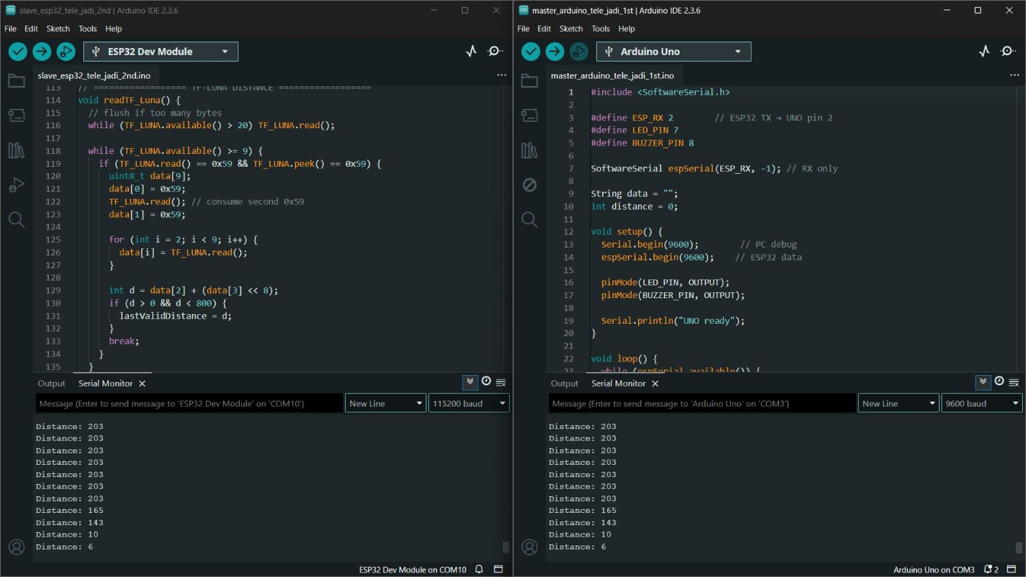
Figure 5: The code and result

3.2 System 2 (Alert System) Analysis

Results

The results of System 2 show that the Telegram-based emergency alert system works well as a real-time notification platform. As seen in the Telegram interface, warning messages like "DANGER!" "Object too close!" is sent every time the system finds a dangerous situation. This shows that the system can keep an eye on environmental conditions all the time and send out alerts when the set proximity limit is broken. In assistive and IoT-based warning systems, messaging platforms have been used for safety notifications, and they have been shown to work (Keerthi et al., 2023; Kumar et al., 2024).

Along with danger alerts, the system sends out a status notification that says "System Started (Face Authorised)." This checks that the system has started up and that the user has been authenticated before sending out alerts. This feature makes the system more reliable by making sure that alerts are only sent after authorised activation. This lowers the chance of false or unwanted notifications. Authentication-based activation has been emphasised as a crucial design aspect in assistive technologies to maintain system integrity and user trust (Elmannai & Elleithy, 2017).

The timestamps in the Telegram messages show that alerts are sent out quickly. When an object stays within the critical distance, repeated warning messages are sent. This shows that the microcontroller and the Telegram bot can still detect the object and communicate with each other over the internet. In emergency and assistive applications, where quick response greatly increases user safety (Anik et al., 2021), this real-time performance is very important.

The results show that Telegram is a good way to send emergency alerts because it lets you send notifications right away, make them available to everyone, and keep track of them from a distance using a mobile device.

Discussion

Adding Telegram as the main alert tool makes the emergency alert system much more useful. Instant messaging platforms make sure that important alerts are never missed by sending them even if the user is not close to the device. Previous research on IoT-based assistive systems indicates that mobile notification platforms enhance situational awareness and response time in hazardous environments (Keerthi et al., 2023; SpringerLink, 2023).

The repeated sending of "DANGER! Object too close!" messages shows a safety-first design philosophy, where alerts stay on until the dangerous situation changes. This strategy makes things more reliable, but it might also mean too many notifications when you're around obstacles for a long time. Similar problems have been found in proximity-based alert systems, where too many notifications can make users less responsive (Elmannai & Elleithy, 2017). This limitation could be lessened in future work by adding alert throttling, delay intervals, or ways for users to confirm that they got the alert.

Adding system status notifications makes users even more sure that the system is working properly and is active. This openness is especially important in assistive technologies, where users rely on the system's reliability for their own safety (Anik et al., 2021). Telegram's ability to store message history also makes it a useful log for looking back and evaluating the system after an event.

In the end, System 2 does a good job of meeting its goal of making Telegram a quick, reliable, and easy-to-use emergency alert system. The system has a lot of potential for real-world assistive uses, especially for people who are blind or have low vision, where immediate danger notification and remote monitoring are very important. The system's effectiveness and user experience can be improved even more by making alert frequency control and system optimisation even better.

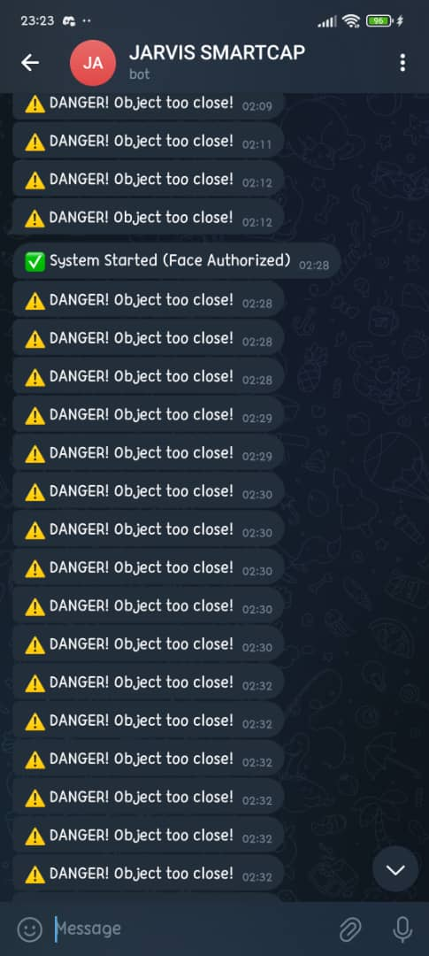

Figure 6: Telegram system

4. CONCLUSION

This project successfully developed a wearable Smart Cap designed to assist blind users during outdoor movement by detecting head-level obstacles and providing real-time guidance. By integrating a TF-Luna LiDAR sensor and a HuskyLens vision sensor with an Arduino UNO microcontroller, the system is capable of accurately identifying obstacles and delivering timely feedback through visual and auditory warning mechanisms. The use of a simplified two-tier system architecture enhances reliability while maintaining low design complexity, making the Smart Cap suitable for wearable assistive applications.
Experimental results demonstrate that the Smart Cap performs effectively under various obstacle distances and user movement conditions, confirming its ability to detect head-level hazards that are often overlooked by conventional mobility aids. The distance-based warning intensity allows users to intuitively understand obstacle proximity, improving reaction time and overall safety during navigation. The standalone operation of the system further supports its practicality for daily outdoor use without dependence on external computing devices.
Overall, the proposed Smart Cap contributes to safer and more independent mobility for visually impaired individuals by addressing critical head-level obstacle detection in outdoor environments. Future improvements may include the integration of haptic feedback, miniaturization of hardware components, and enhanced AI object classification to further improve usability, comfort, and system intelligence. With these enhancements, the Smart Cap has strong potential to serve as a reliable, low-cost wearable assistive technology for the visually impaired.
Acknowledgment
The authors would like to thank the course lecturer and the Mechatronics System Integration laboratory staff for their guidance, support, and assistance throughout the completion of this project.
Conflict of Interest
Authors declare that there is no conflict of interest regarding the publication of the paper.
Author Contribution
All authors contributed equally to the planning, design, implementation, testing, analysis, and documentation of this project. All authors have read and approved the final version of the report.

REFERENCES

[1] World Health Organization, “World Report on Vision,” 2019.
[2] M. B. Alam et al., “Smart Blind Kit: Arduino-Based Wearable Assistive Device for Real-Time Obstacle Detection,” Spectrum of Engineering Sciences, vol. 3, no. 8, pp. 608–618, 2025. :contentReference[oaicite:1]{index=1}
[3] “Sensor-Based Prototype of a Smart Assistant for Visually Impaired People — Preliminary Results,” MDPI Sensors, 2022. :contentReference[oaicite:2]{index=2}
[4] A. Chakraborty, “Smart Cap: A Sensor Based Low-Priced Assistant for the Blind and Visually Impaired People,” TechRxiv preprint, Aug. 5, 2022. :contentReference[oaicite:3]{index=3}
[5] Anik, F. I., Nahiyan, M. H. A., Salehin, M. N., & Hasib, M. I. (2021). Development of a sensor assistive walking stick for the visually impaired. European Modern Studies Journal.
[6] Kumar, U. S., et al. (2024). A smart walking stick with ultrasonic sensor for supporting the visually impaired people. African Journal of Biomedical Research.
[7] Keerthi, U., et al. (2023). IOT based smart blind stick. IJRASET.
[8] Palleja, T. (2023). Laser sensing and vision sensing smart blind cane: A review. MDPI Sensors.
[9 ]Elmannai, W., & Elleithy, K. (2017). Sensor-based assistive devices for visually-impaired people. MDPI Sensors.
[10] (2023). The smart cane for a confident journey aiding the visually impaired. SpringerLink.
[11] Benewake (2024). TF-Luna LiDAR low-cost distance sensor. Benewake.

